Lance Holt School
Policies and Procedures

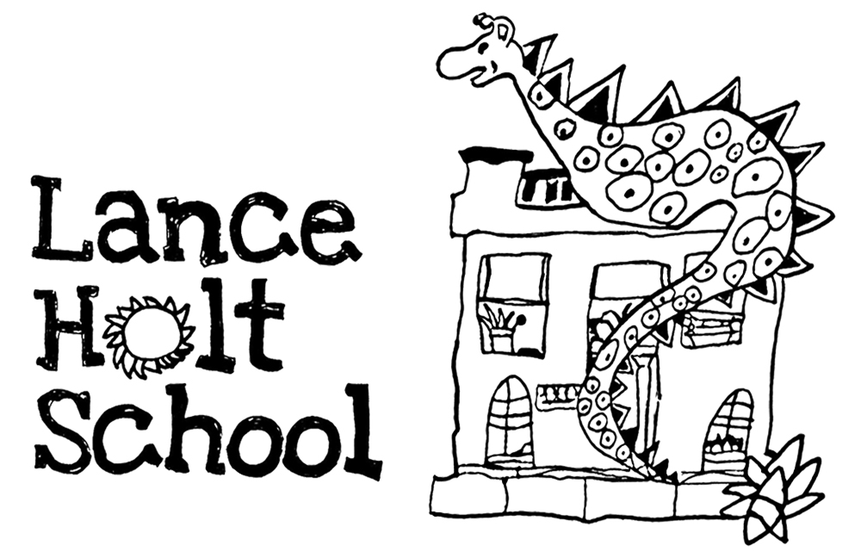

Fundraising and Donations

Refund Policy and Terms and Conditions

Version Management

Version | Date Published | Changes Made | Author of Changes | Review Date
1 | 2022 | Policy created for online fundraising platform | CS/SB | 2024

Fundraising and Donations Policy

1. Policy Statement

2. Fundraising and Donations

2.1 Refund Policy
2.2 Privacy Policy
2.3 Purpose of your Donation
2.4 Declining a Donation

3. Events and Tickets

3.1 Terms and Conditions

4. Merchandise

5. Effective Date

6. Next Review Date

1. Policy Statement
The Lance Holt School Fundraising and Donations Policy provides the procedures for accepting donations and fundraising funds, outlines the refund policy and the terms and conditions associated with event tickets. This policy may be updated or revised from time to time as required.
2. Fundraising and Donations

2.1 Refund Policy
Due to the nature of charity donations and fundraising, refunds are given at the discretion of our
school management. Donations will only be refunded if genuinely made in error. Please make sure
that the amount you enter is the amount you wish to give.

In the event of an incorrect amount being entered, or if the donation is made accidently or there is
an unusual circumstance, please contact us in writing. On receipt of written notification we will
review the request and respond within five working days.

If the donation is refunded, the associated tax receipt is no longer truthful so should be
destroyed.

2.2 Privacy Policy
LHS respects the privacy of all individuals, companies and community organisations who donate
money and/or goods in support of our school. Personal information gathered through donations is
entered into a secured database for receipting and communications purposes. We will collect, use
and disclose personal information in accordance to our Privacy Policy

2.3 Purpose of your Donation
LHS will always aim to honor the agreed purpose of a donation. However, we have ultimate
unconditional discretion to redirect the donation if necessary.

2.4 Declining a Donation
LHS has ultimate discretion to decline a donation.

3. Events and Tickets

3.1 Terms and Conditions
The following Terms and Conditions will help all families to enjoy the event for which tickets have
been purchased. Tickets entitle the holder to attend the event at the date, time and location
stated on the ticket. By purchasing a ticket the buyer and/or holder agrees to the following.
- It is the responsibility of the buyer to ensure all the details are correct at the time of purchase. The ticket may not be exchanged, refunded or returned except in accordance with Australian consumer Law and/or at the discretion of school management.
- The right is reserved to vary the advertised program and content as necessary.
- The right of admission is reserved including where entry is delayed for late arrivals, refused or where an attendee is asked to leave the premises.
- The recording of an event using any device is prohibited unless otherwise advised.

4. Merchandise

If you are not satisfied with the purchased product we are happy to exchange it or refund your purchase price. This is in addition to your rights under Australian Consumer Law. Please contact the school office to arrange a refund/exchange.

5. Effective Date: Created 2022

6. Next Review Date: 2024

